SW Banking Application Report

# 1. Real World Problem Identification

With the increasing digitization of financial services, users demand secure and convenient access to banking. Traditional banking systems often require physical branch visits, leading to time constraints and accessibility issues. Many users prefer to manage essential banking tasks, such as balance inquiries, fund transfers, and account management, through mobile applications, thus reducing reliance on physical branches.

To meet these needs, the SWBank mobile application provides a secure, user-friendly, and responsive platform for managing daily banking tasks. The app enables users to check balances, transfer funds, view account details, and reset passwords if needed, all from a single application. This approach enhances accessibility and streamlines daily financial management, addressing key challenges in traditional banking.

# 2. Proposed Solution

The SWBank mobile application was developed to simplify and digitize core banking features for mobile use. The app provides a comprehensive set of functions:

* **User Authentication:** Secure login and registration are facilitated through Firebase Authentication, ensuring only authorized users gain access.
* **Balance Inquiry:** Users can view their current account balance easily.
* **Money Transfer:** The app allows secure fund transfers between accounts, with built-in balance checks to prevent overdrawn accounts.
* **Account Details:** A dedicated screen displays essential account information, such as the account number, account holder's name, and address.
* **Password Reset:** For security, the app allows users to reset forgotten passwords after verifying their credentials.
* **User-Friendly Interface:** With a modern, visually appealing interface featuring gradient backgrounds, the app ensures a consistent and engaging user experience.

By leveraging Firebase services and Flutter's cross-platform framework, the SWBank app delivers a reliable and accessible banking solution that meets users’ needs efficiently.

3. Responsive User Interfaces

The SWBank app is designed with responsiveness in mind, ensuring that the user interface adjusts fluidly across different screen sizes and device orientations. The following screenshots illustrate the app’s adaptive UI on various devices, ensuring usability and consistency

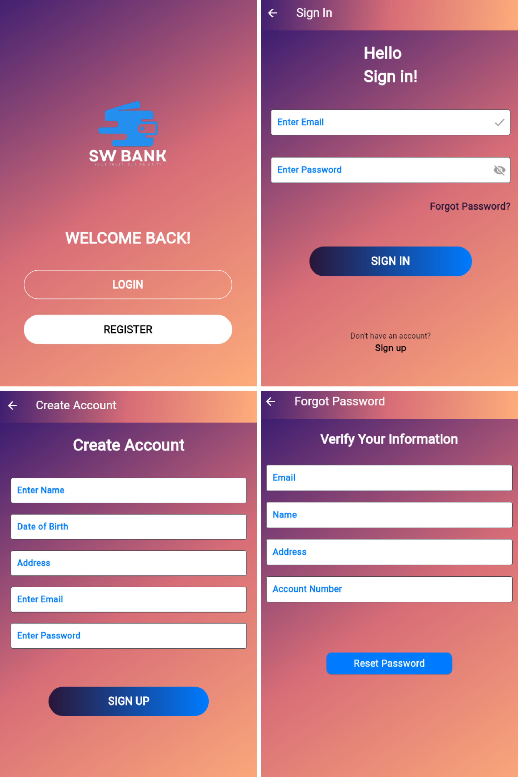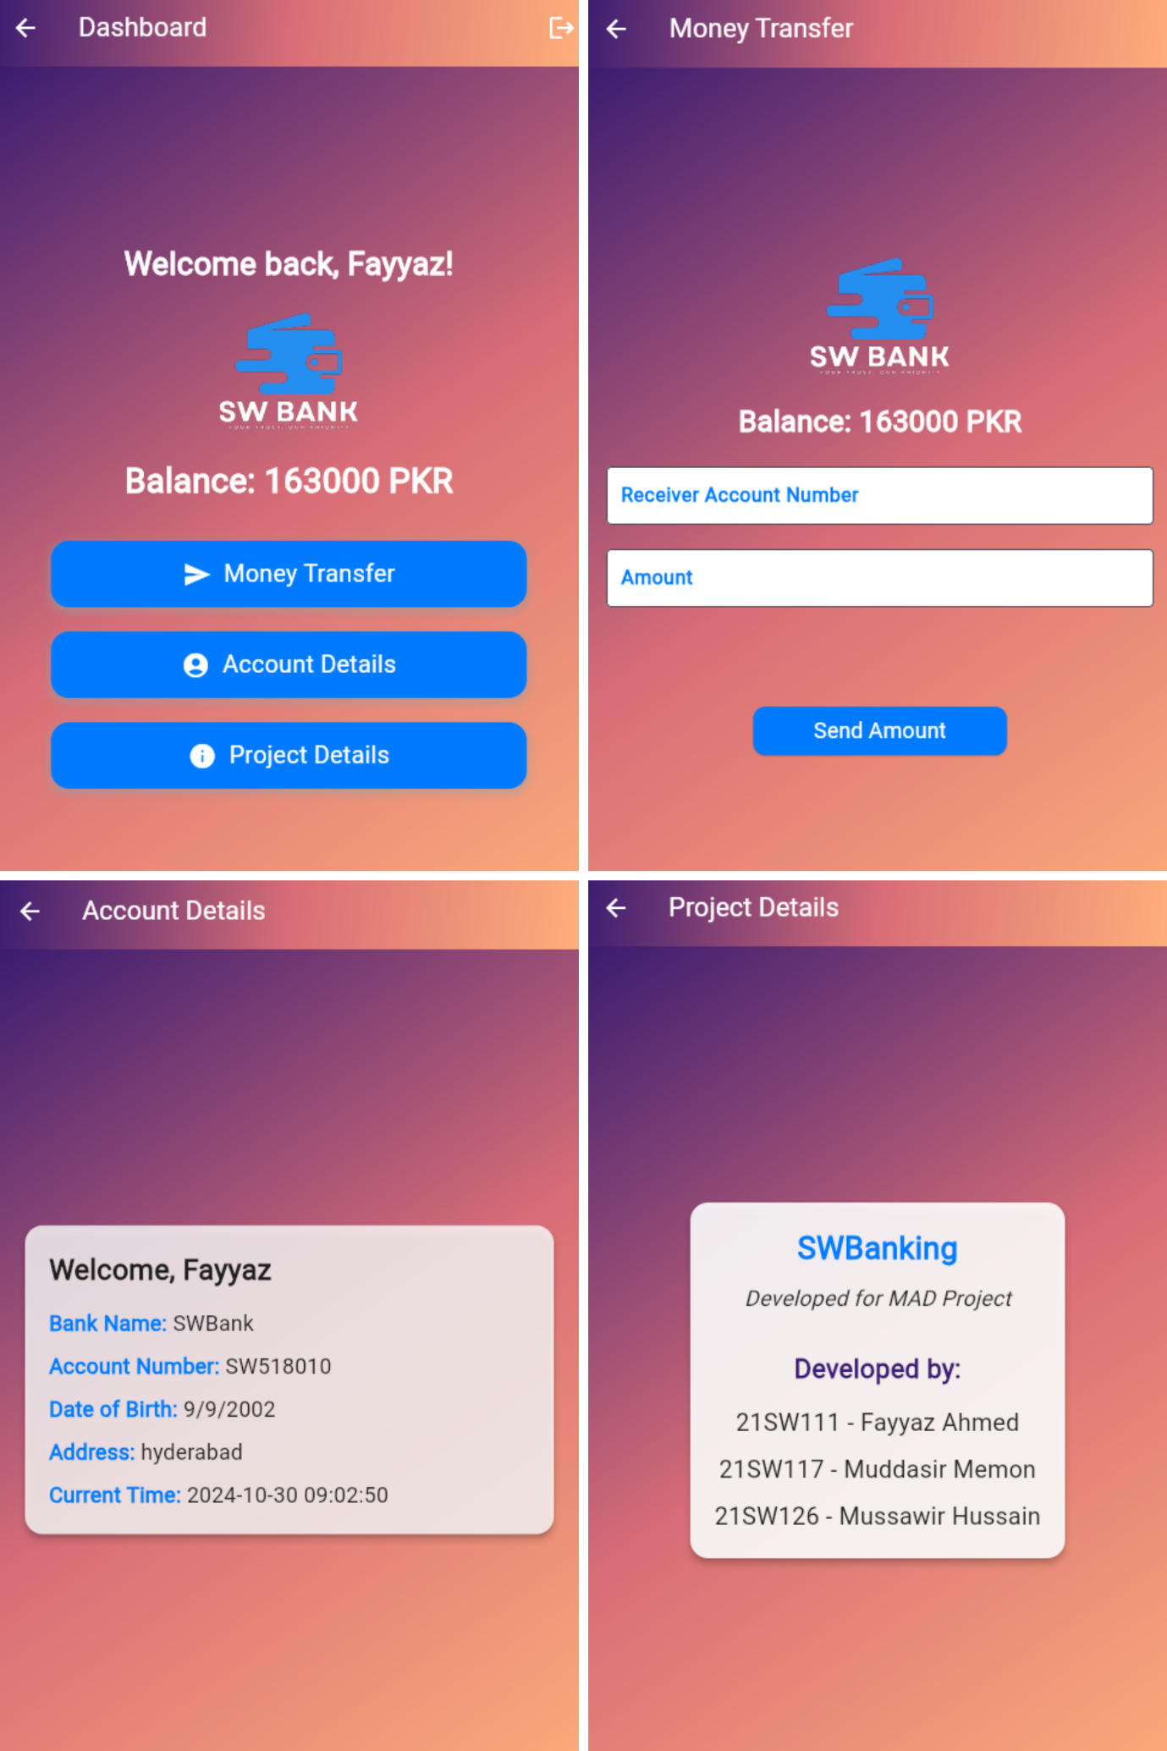

# 4. Data Storage

The SWBank application uses Firebase Firestore as its database solution due to its alignment with the app’s requirements:

* **Real-time Data Synchronization:** Firestore offers real-time updates, enabling users to view their current balance and transaction history instantly.
* **Scalability:** Firestore's auto-scaling capabilities accommodate growth in both user base and data volume, making it suitable for large-scale applications.
* **Security:** Firebase Authentication, combined with Firestore’s security rules, ensures robust protection of user data against unauthorized access.
* **Ease of Integration:** Firestore’s seamless compatibility with Firebase Authentication allows for straightforward linking of user data to authenticated accounts.
* Firestore’s combination of features—real-time syncing, security, scalability, and easy integration—makes it an ideal choice for secure and responsive data handling in mobile banking.

5. APIs, Packages, and Plugins

To ensure the SWBank app's functionality, several key packages and plugins were used:

* **Firebase_auth:** Manages user authentication processes, including login, registration, and password resets, providing a secure, easy-to-integrate solution for credential management.
* **Cloud_firestore:** Used for storing and retrieving user data, cloud_firestore offers a scalable NoSQL database solution with seamless Firebase integration.
* **INTL**: Enables internationalization and localization, allowing date and time displays to be formatted accurately, such as showing the current time on the dashboard.

# 6. Issues and Resolutions

During the SWBank app's development, several issues arose, which were addressed to enhance app functionality and user experience:

* **Responsive Layout Adjustment**: Ensuring the app was fully responsive across various screen sizes required fine-tuning. This was achieved by utilizing Flutter’s media query and layout widgets to adjust padding, font sizes, and alignment dynamically.
* **Authentication Error Debugging:** Errors arising from incorrect login credentials were challenging to trace initially. Improved error messages and user input validation were implemented to guide users in resolving these issues.

**Report Submitted By:**

1. **21SW111 (Fayyaz Ahmed)**
2. **21SW117 (Muddasir Memon)**
3. **21SW126 (Mussawir Hussain)**